For [[click here if you would like to open this page in its own window]](https://docs.google.com/document/d/1Ca7kGLO5XyKVIY6yFDB5_tdTcdyOKyFRyGMw1T08KqQ/edit?usp=sharing) **SQL HW #4: Multi-table Selects**

For SQL HW4, you will be you will use the tables that you created for SQL HW1, which should be in your "BIS235" database.

Devise the appropriate SQL queries for each of the requests below. To receive full credit your response must be a single SQL query. Include in your response both the query that you issued and the output that was returned. Be sure to include ONLY your final query and the resultant output. If you include parts of your initial attempts or extraneous output, you may lose points for doing so. To receive full credit for your work you must also LABEL each answer with its appropriate question number.

Where not otherwise specified, you may return all columns in a given query (i.e. you may use “SELECT * …”)

The PK-FK relationships for the tables you will be querying in this exercise will be useful for your reference in understanding the relationships between the tables, and is as follows:

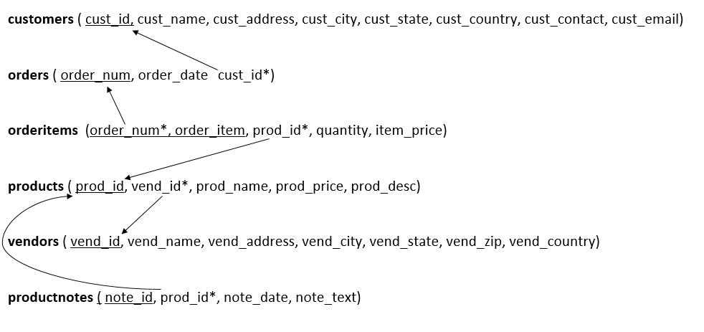

Note that the PK-FK pairs share the exact same attribute name in all related tables, so whether by understanding the translation (the prefered method), or by looking for common attribute names, you should be able to figure out the nature of the relationships among the tables.

Also note that because the PK-FK attributes share the same names, you must pre-pend table names to distinguish which attribute you are referring to, as in the following:

SELECT * from products, vendors WHERE products.vend_id = vendors.vend_id

1. Find the customer IDs of all of the customers who have ordered the product whose ID is ‘TNT2’.
2. Find the customer names and cust_contacts for all of the customers who have ordered the product whose ID is ‘TNT2’.
3. Return all of the vendors, the products they sell and their respective prices. Return the results ordered alphabetically, first by vendor name, then by product name.
4. Display the product name, vendor name, product price and quantity ordered for order number 20005.
5. Which customers have placed orders for products that have a product note associated with them?